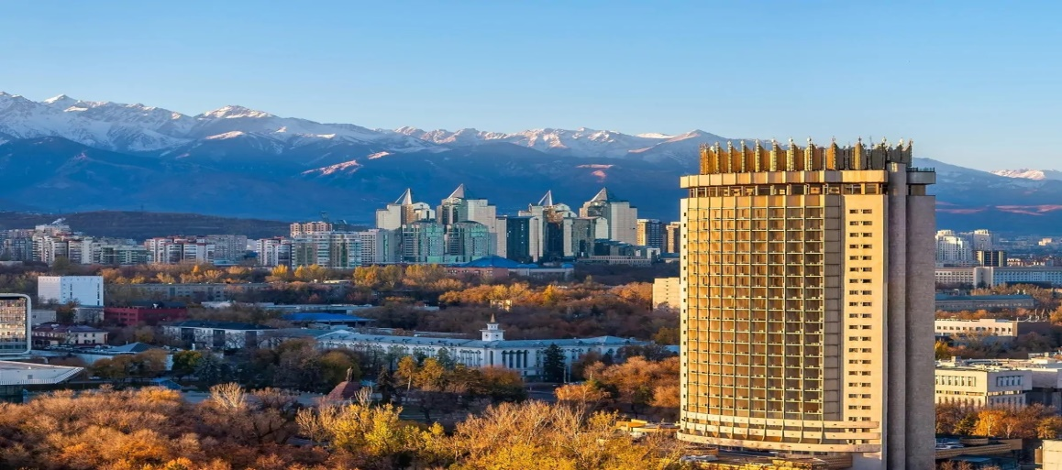
Day 2 – Almaty City Tour

The Golden Square in Almaty, Kazakhstan, is a historic downtown neighborhood built between 1930 and 1970 to house the Soviet elite, prominent poets, politicians, and artists.

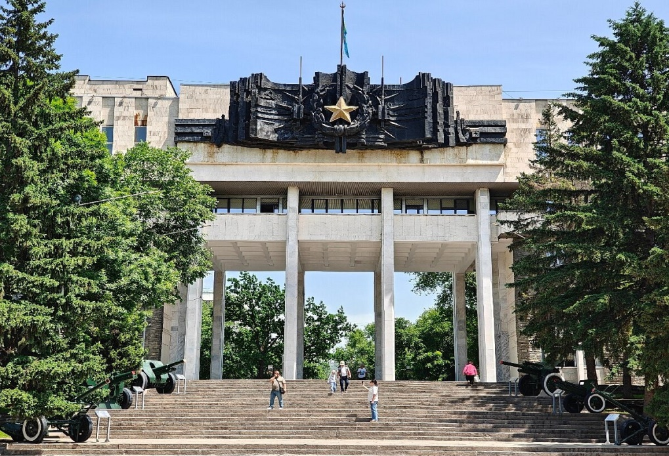

The 28 Panfilov Guardsmen Park in Almaty, Kazakhstan, is an 18-hectare public green space with a history dating back to the 1870s

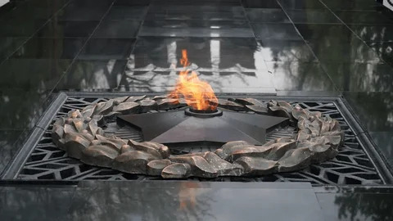

The Eternal Flame in Almaty was lit on May 8, 1975, to mark the 30th anniversary of the Soviet victory in World War II
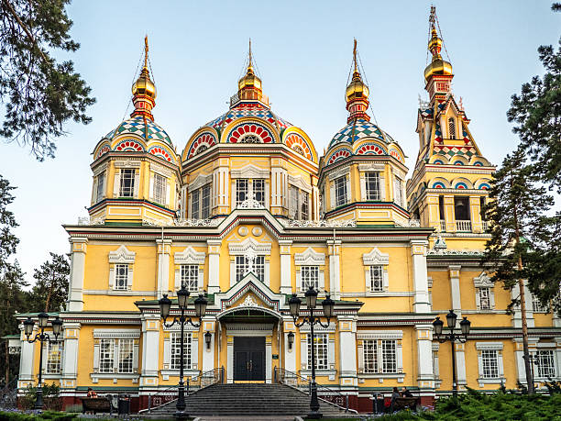

The Ascension Cathedral, also known as the Zenkov Cathedral, is a 56-meter-tall Russian Orthodox church in Almaty's Panfilov Park.

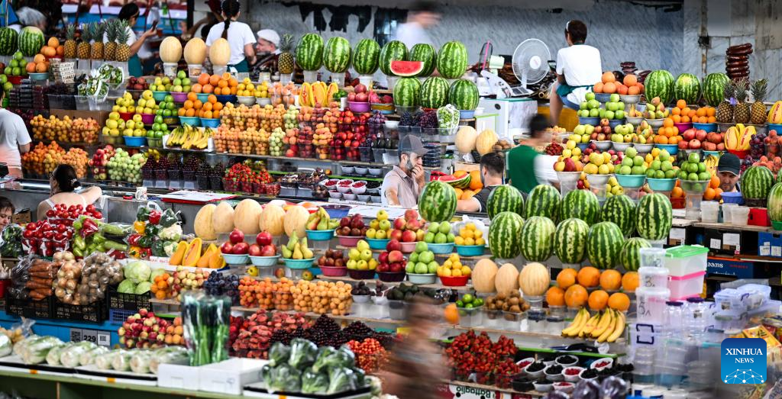

The Green Bazaar in Almaty, Kazakhstan, is one of the oldest and most iconic public markets in Central Asia, tracing its trading roots back to the 19th century.

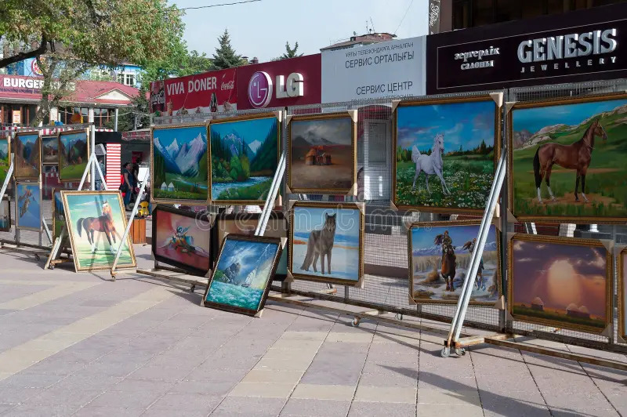

Arbat Shopping Street in Almaty, also known as Zhibek Zholy Street, is the city's oldest trading route turned into its very first pedestrian zone.

Day 3 – Charyn Canyon & Kolsai Lake
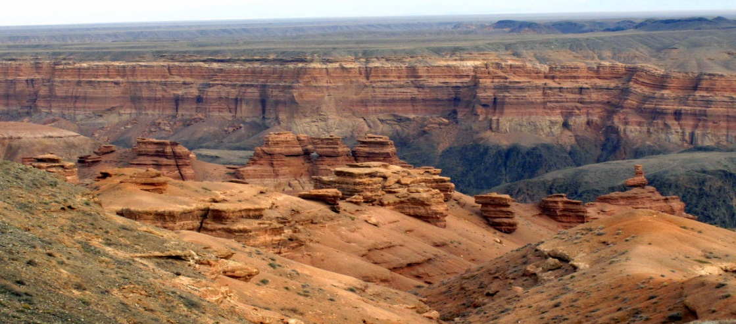

Charyn Canyon in Kazakhstan is a 12-million-year-old natural geological wonder located about 200 kilometers east of Almaty
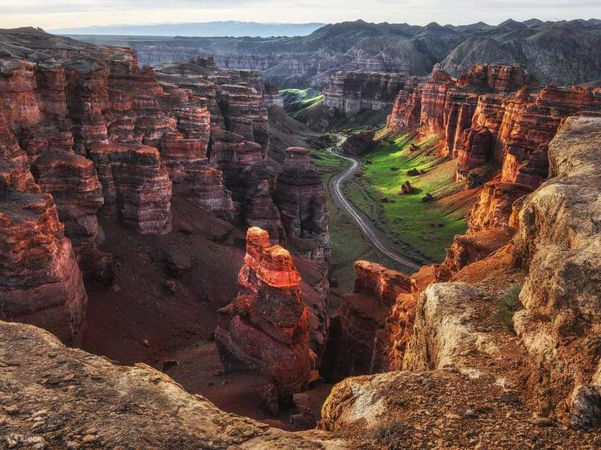

The Valley of Castles is a 12-to-14-million-year-old natural rock formation within the Charyn Canyon in southeastern Kazakhstan

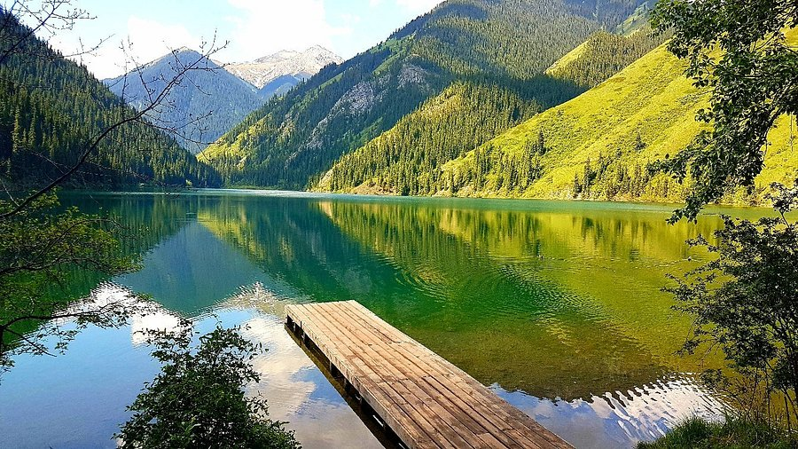

Kolsai Lake is a stunning system of three alpine lakes located in the Northern Tian Shan mountains of southeastern Kolsai Lakes National Park in Kazakhstan.

Day 4 – Kok Tobe • Medeu • Shymbulak
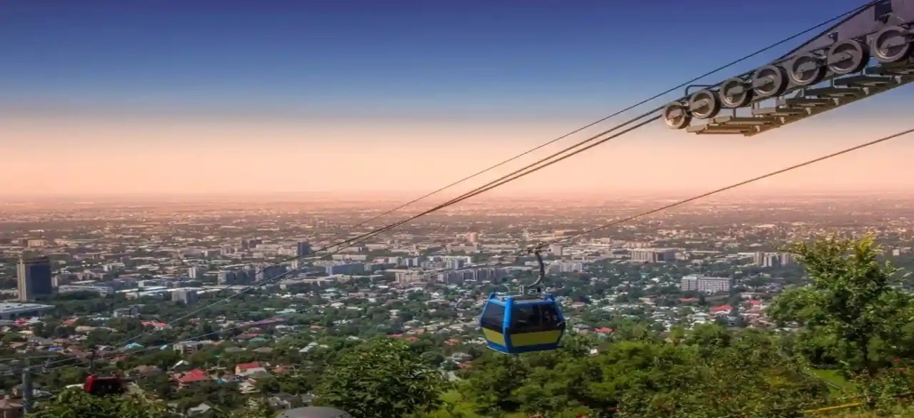

Kok Tobe Hill in Almaty offers a smooth, scenic journey high above the city with breathtaking views of the surrounding mountains.

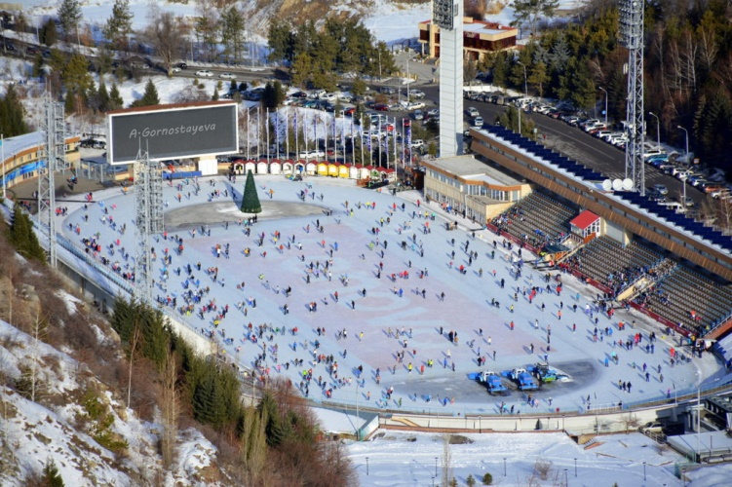

The Medeu Skating Rink in Almaty, Kazakhstan, is the highest Olympic-sized outdoor ice skating rink in the world, sitting at 1,691 meters above sea level.
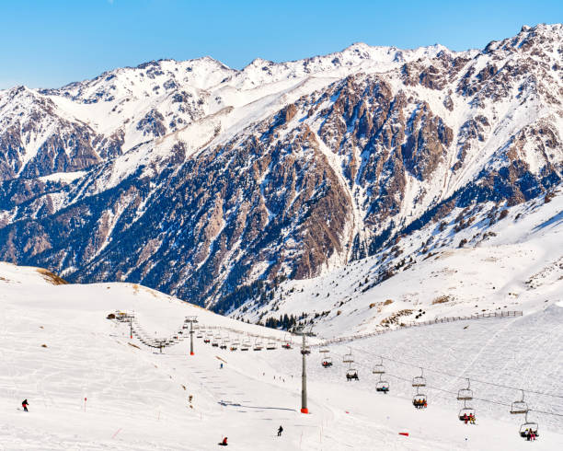

Shymbulak Mountain Resort is the ultimate alpine escape in Central Asia, perfect for capturing the magic of snow-capped peaks, cable car adventures, and cozy mountain vibes
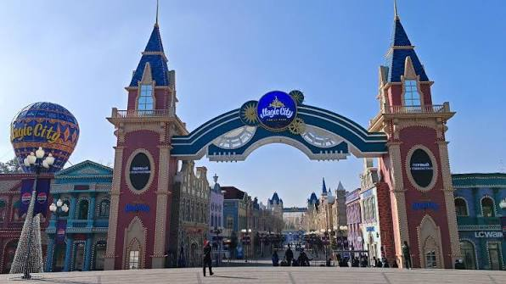
Day 5 – Fly to Tashkent

Magic City Park in Tashkent, Uzbekistan, officially opened on June 1, 2021, to coincide with International Children's Day.
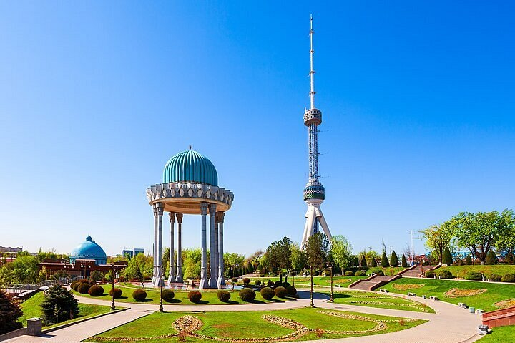

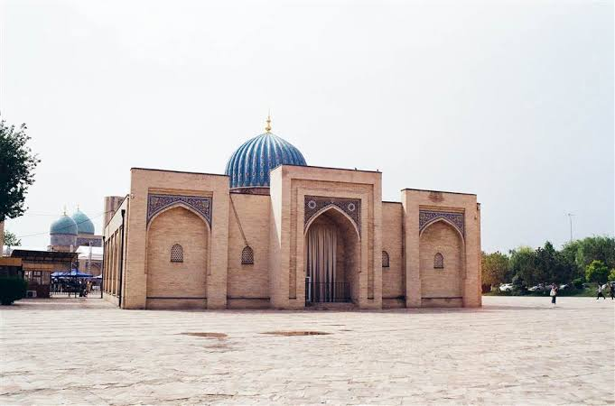
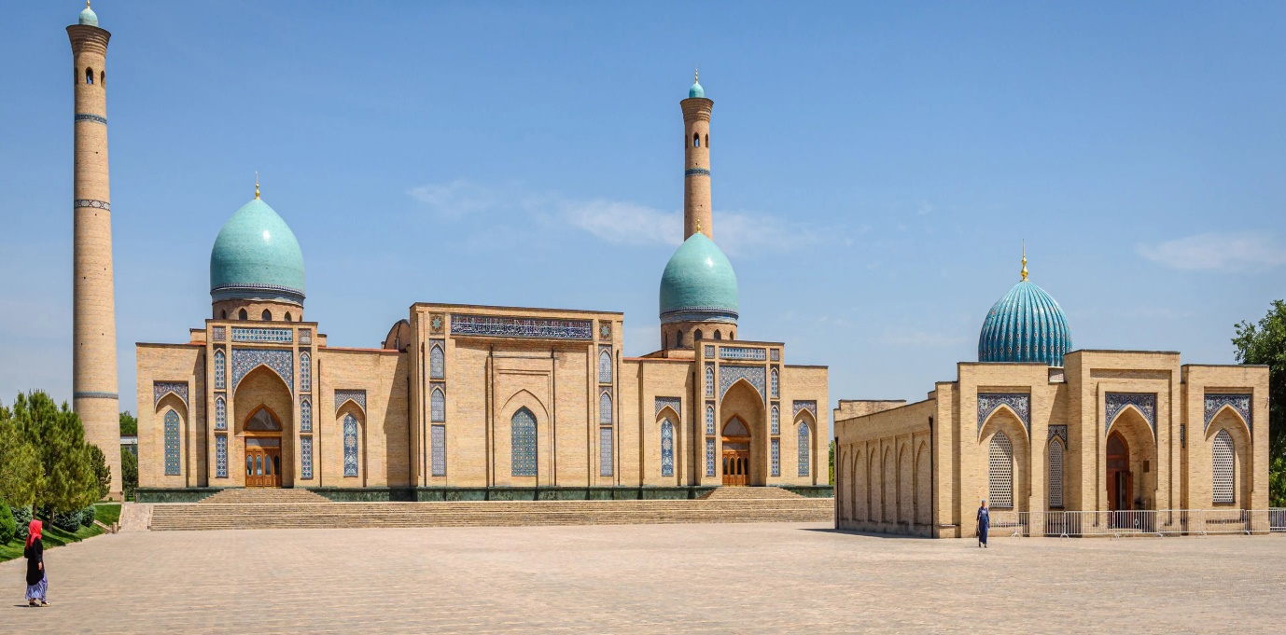

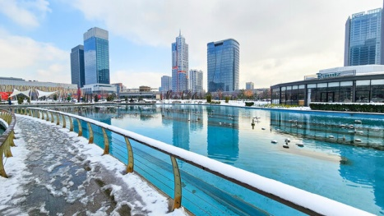

Day 6 – Amirsoy Mountain Tour
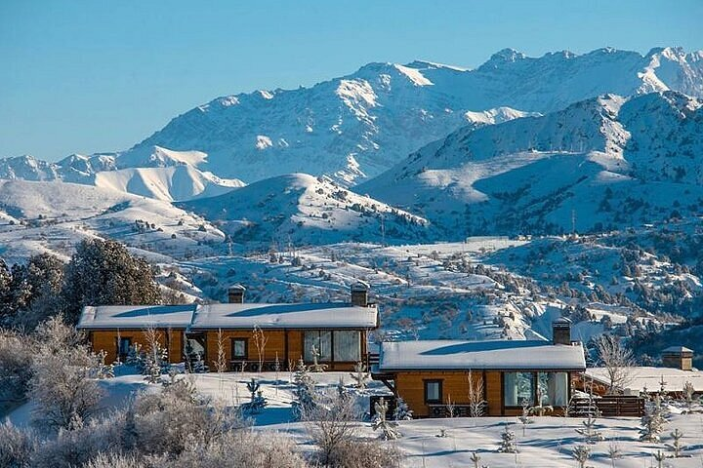

Amirsoy Mountain Resort opened on December 21, 2019, as the largest and most modern ski resort in Uzbekistan and Central Asia
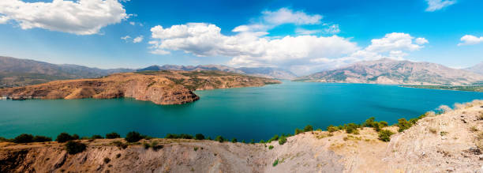

The Chimgan Mountains in Uzbekistan have a rich history as an ancient green valley, a tsarist-era retreat, and a famous Soviet-era mountaineering and ski hub
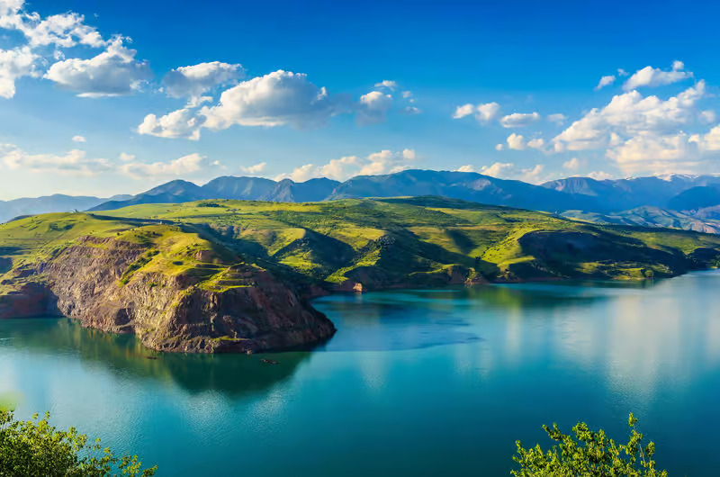

Lake Charvak is an artificial reservoir in the Boʻstonliq District of the Tashkent Region in Uzbekistan, created in 1970 by building a massive 168-meter-high rock-fill dam across the Chirchiq Rive.

Day 7 – Samarkand Excursion
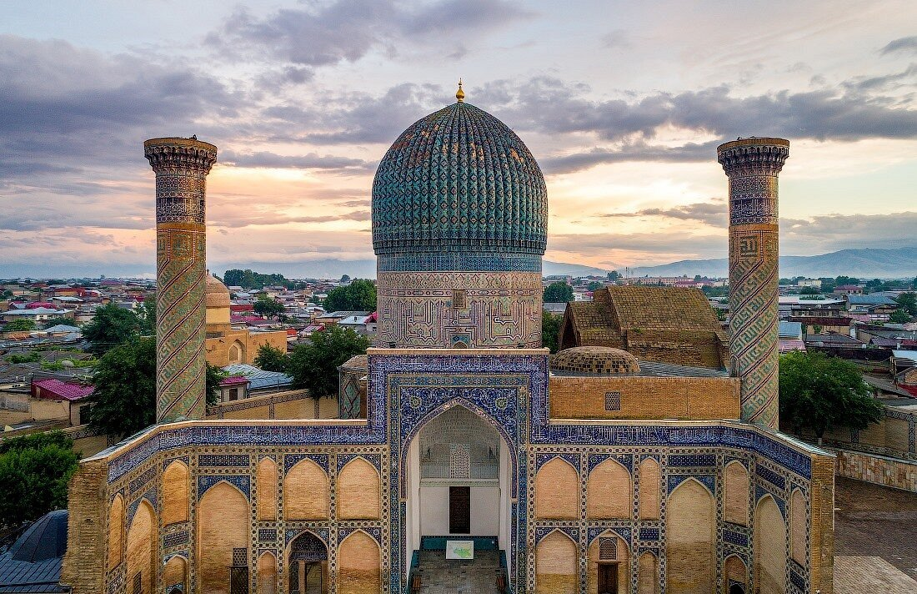

The Gur-e-Amir in Samarkand, Uzbekistan, is the majestic mausoleum and final resting place of the 14th-century conqueror Timur, also known as Tamerlane.

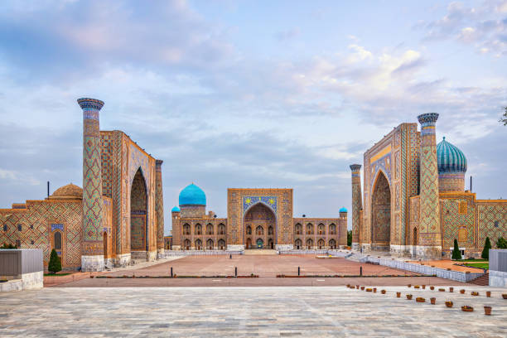

Registan Square in Samarkand, Uzbekistan, is a historic public square that served as the heart of the Timurid Empire and a central hub of the Silk Road

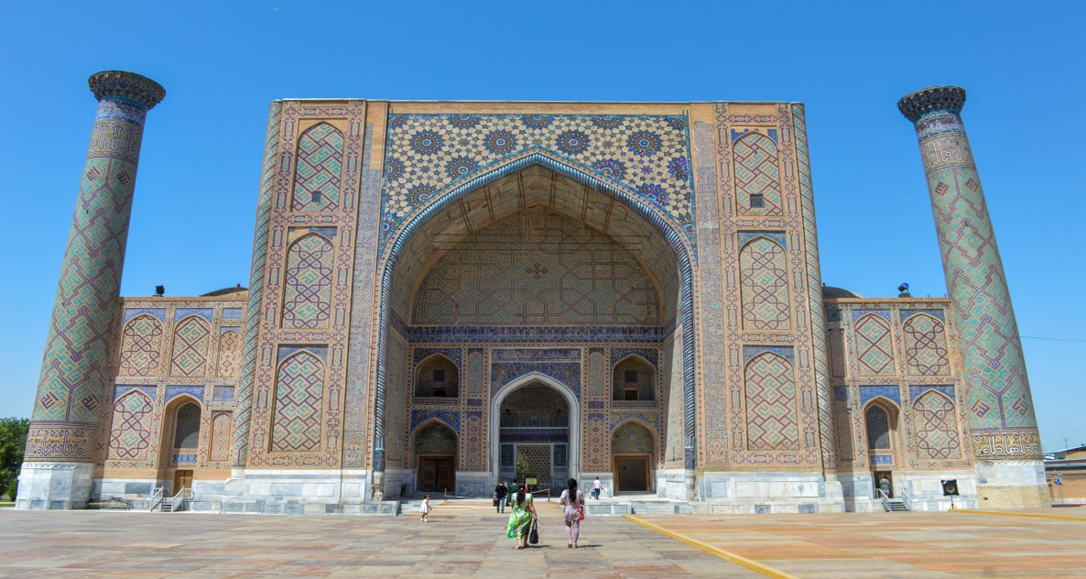

The Ulugh Beg Madrasa in Samarkand, Uzbekistan, was built between 1417 and 1421 by the Timurid ruler and astronomer Ulugh Beg.
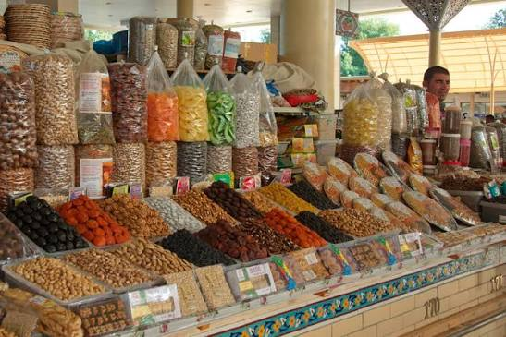
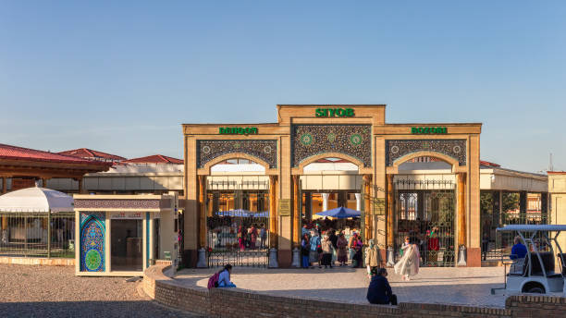

Siab Bazaar in Samarkand, Uzbekistan, is most famous for its iconic, round Samarkand non (flatbread), fresh Zarafshan Valley produce, and vibrant rows of dried fruits and aromatic spices

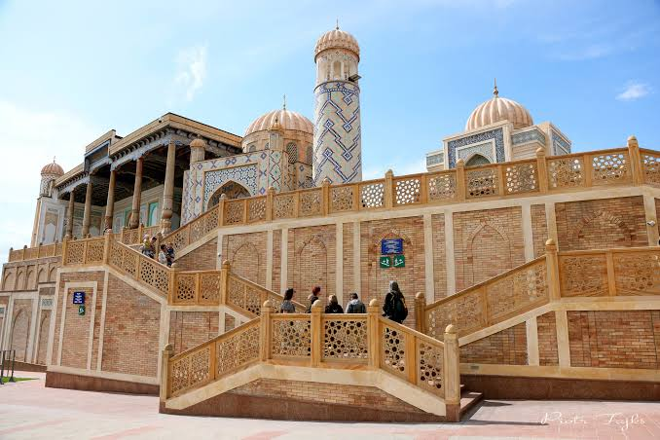

The Hazrat Khizr Mosque in Samarkand, Uzbekistan, is an ancient Islamic landmark dating back to the 8th century, built on the site of a revered pre-Islamic Zoroastrian temple.

Day 8 – Tashkent City Tour
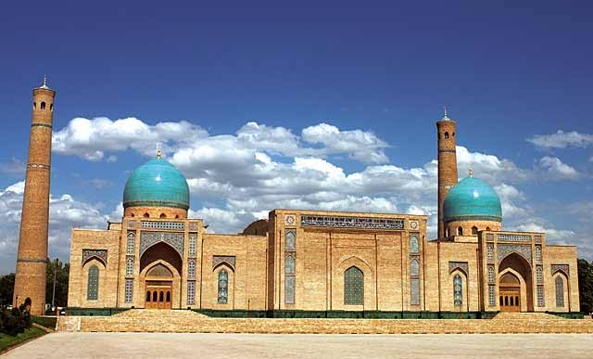

The Hazrati Imam Complex in Tashkent, Uzbekistan, is a historic religious and architectural ensemble dating from the 10th to the 21st centuries.
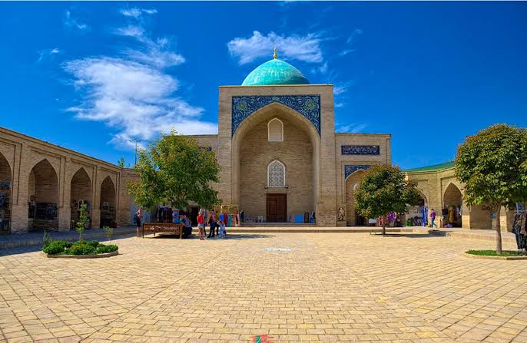

The Barak-Khan Madrasah is a 16th-century architectural monument located on Hast-Imam Square in Tashkent, Uzbekistan.

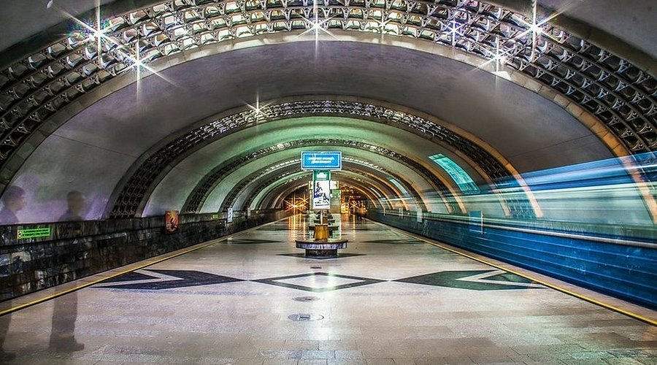

The Tashkent Metro opened on November 6, 1977, as the first underground rapid transit system in Central Asia.

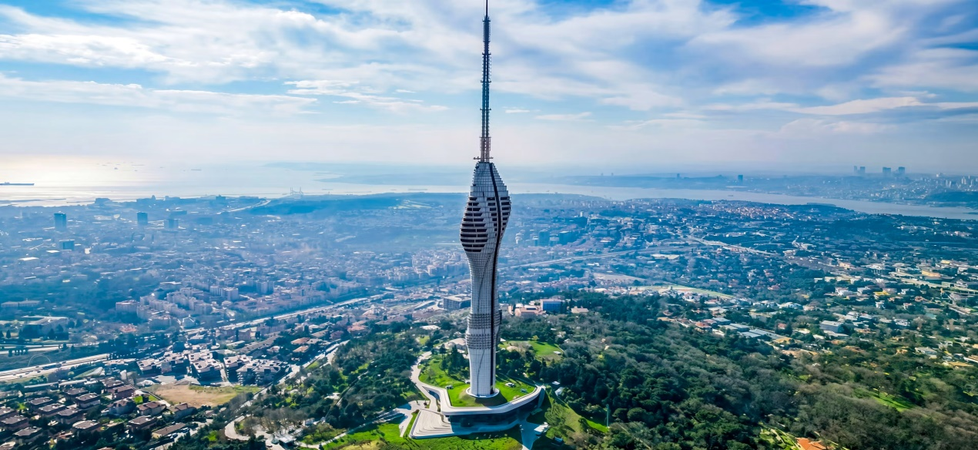

Outdoor television towers originated in the mid-20th century as monumental engineering landmarks designed to broadcast terrestrial signals across vast distances
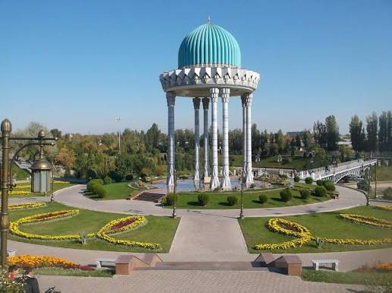

The State Museum of Memory of Victims of Repression in Tashkent, Uzbekistan, is a memorial complex dedicated to honoring those who suffered and died under tsarist colonial rule and Soviet totalitarian regimes.

Day 9 – Shopping Tour
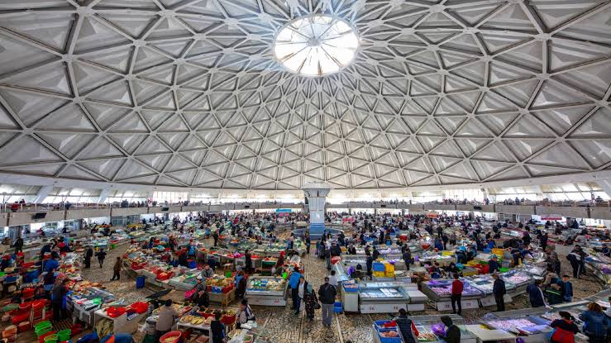

Chorsu Bazaar in Tashkent is famous for its vibrant central food dome, traditional Uzbek flatbreads, and authentic local delicacies like shashlik and kazy
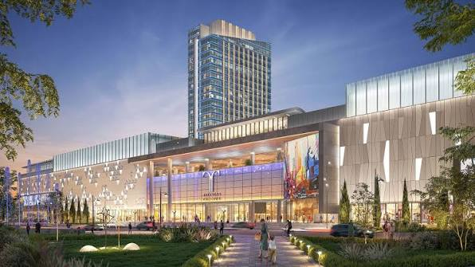

Tashkent City Mall is the largest and most luxurious shopping center in Uzbekistan, specializing in bringing over 250 global fashion brands, high-end luxury retail, and international dining concepts to the capital for the first time.

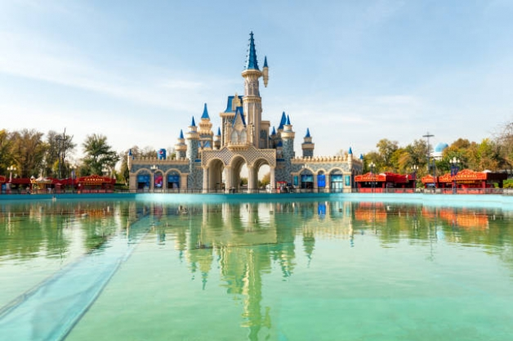

Tashkent City Park is a modern, 18-hectare urban oasis in the center of Tashkent featuring vibrant musical fountains, green spaces, and contemporary architecture.

